MOVIE TICKET BOOKING SYSTEM

Required Ananlysis

Functional Requirements:

- FR1 : The system shall display a list of all movies currently playing in the cinema.

- FR2 : The system shall display all available shows for a selected movie along with the screen number and start time.

- FR3 : The system shall display the seat layout of a selected show with the status of each seat as AVAILABLE or BOOKED.

- FR4 : The system shall allow the customer to book one or more seats and shall reject any seat that is already booked.

- FR5 : The system shall calculate the total booking amount based on the type of each selected seat: SILVER ₹150, GOLD ₹250, and PLATINUM ₹400.

- FR6 : The system shall support payment through UPI, Card, or Cash, and a failed payment shall not confirm the booking.

- FR7 : The system shall print a ticket containing the booking ID, movie name, screen number, show time, booked seat numbers, and total amount.

- FR8 : The system shall allow a customer to cancel an existing booking and make all seats associated with that booking AVAILABLE again.

Non-Functional Requirements:

- NFR 1: The system shall be modular, with each class maintained in a separate source file and each function performing a single responsibility.

- NFR 2: The system shall be extensible so that a new payment method can be added without modifying existing payment implementations or the booking flow.

- NFR 3: The system shall validate invalid menu choices, seat numbers, and booking inputs and display a clear error message without crashing.

- NFR 4: The code shall be maintainable by using meaningful names, avoiding duplicated code and magic numbers, and keeping functions reasonably small.

Noun Analysis Table:

Noun Found | Keep as a class? | Reason
Customer | Yes | Has its own data such as name and phone and interacts with the booking system.
Movie | Yes | Has its own identity and data such as title, language and duration.
Show | Yes | Represents a particular screening of a movie on a screen at a specific time.
Screen | Yes | Represents one auditorium and owns its physical seats.
Seat | Yes | Represents one physical seat with a number and seat type.
Seat Layout | No | It is only a view/representation of a show's seats, so it can be handled by a display method.
Booking | Yes | Represents a customer's reservation and contains booking information such as ID, seats, amount and status.
Ticket | No | The assignment treats ticket printing as a responsibility of TicketPrinter; a separate Ticket entity is not required.
Payment | Yes | Represents the payment contract and is required as an abstraction for different payment methods.
Cinema | Yes | Represents the theatre and owns its screens.
UPI | No | It is a payment method, so it is represented through UpiPayment, which inherits from Payment.
Card | No | It is a payment method, represented through CardPayment.
Cash | No | It is a payment method, represented through CashPayment.
Price | No | Price is data used for calculating the booking amount, not an independent entity.
Seat Type | No | It can be represented as a type/value such as SILVER, GOLD, or PLATINUM within the seat.
Booking ID | No | It is an attribute of Booking, not an independent object.

Verb Analysis Table:

Verb | Posible Method | Class
List Movies | listMovies() | Cinema/Booking
Show shows | getShows() | Movie/BookingService
Display seats | displaySeats() | Show
Book seat | bookSeat() | ShowSeat
Cancel seat | cancelSeat() | ShowSeat
Calculate price | calculateTotal() | PriceCalculator
Pay | Pay() | Payment
Print Ticket | printTicket() | TicketPrinter
Cancel booking | cancelBooking() | Booking
Create booking | createBooking() | BookingService
Check seat status | isAvailable | ShowSeat

Class And Responsibilty Table:

Class | What it knows | Main Responsibility | Must not do
Movie | Title, language,duration | Store and provide movie information | Must not manage seat,booking or payments
Seat | Seat number,seat type | Represent one physical seat and its type | Must not store booking status for a perticular show
Screen | Screen number,seat type | Represent one auditorium and manage its seats | Must not manage booking or payment
Cinema | Cinema name , screens | Represent the cinema and its screens | Must not calculate prices or process payments
Show | Movie, screen, start time, show seats | Represent one screening of a movie and display its seat layout | Must not process payments
ShowSeat | One Seat, status | Track whether a particular seat is AVAILABLE or BOOKED for one specific show | Must not calculate the complete booking price
Customer | Name , Phone | Store customer information | Must not manage payment or seat availability
Booking | Booking ID, show, selected seats, total amount, status | Represent and manage a customer's booking | Must not directly handle payment processing
Payment(abstract) | Payment amount | Define the common payment contract. | Must not implement a specific payment method
UpiPayment | UPI ID | Process payment using UPI | Must not manage bookings
CardPayment | Card information | Process payment using Card | Must not manage bookings
CashPayment | — | Process payment using Cash | Must not manage bookings
PriceCalculator | — | Calculate total price based on selected seat types | Must not book seats or process payments
TicketPrinter | — | Format and print ticket details | Must not perform booking or payment
BookingService | — | Coordinate the complete booking process | Must not contain the individual responsibilities of all other classes
Cinema / Main Menu | Menu/input information | Display menu and read user input | Must not contain booking, payment, or pricing logic

Relationship Table:
No. | Class 1 | Class 2 | Relationship | Justification
1 | Cinema | Screen | Composition | A cinema owns its screens. If the cinema is removed from the system, its screens are also removed.
2 | Screen | Seat | Composition | A screen owns its physical seats. The seats belong to that particular screen and do not exist independently in this model.
3 | Show | Movie | Aggregation | A show uses a movie, but the movie can exist independently and can be used in multiple shows.
4 | Show | Screen | Association | A show is scheduled on a screen, but both the show and screen can exist independently.
5 | Show | ShowSeat | Composition | ShowSeat stores the availability of a seat for one particular show. If the show is removed, its ShowSeat objects are no longer needed.
6 | Booking | Customer | Association | A booking is associated with a customer, but the customer can exist without a booking.
7 | Booking | ShowSeat | Aggregation | A booking uses selected ShowSeats, but ShowSeats belong to the show and can exist independently of a particular booking.
8 | Booking | Payment | Association | A booking is associated with a payment transaction, while payment is handled independently through the payment abstraction.
9 | Payment | UpiPayment / CardPayment / CashPayment | Inheritence | UPI, Card and Cash are different types of payment and inherit the common Payment interface/contract.
10 | BookingService | Booking | Association | BookingService creates and manages bookings, while a Booking can exist as an independent object after creation.

Demo: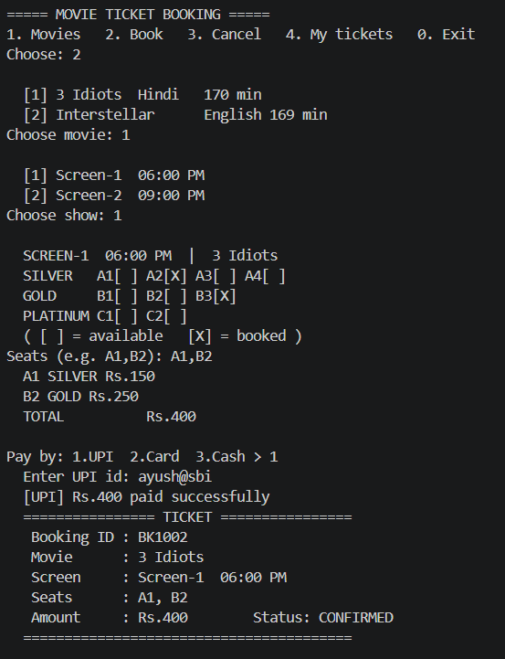

Edge case 1:
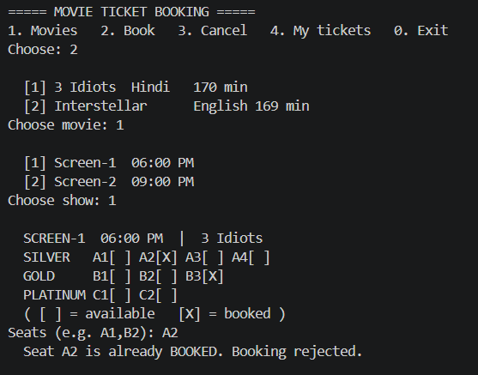

Edge case 2: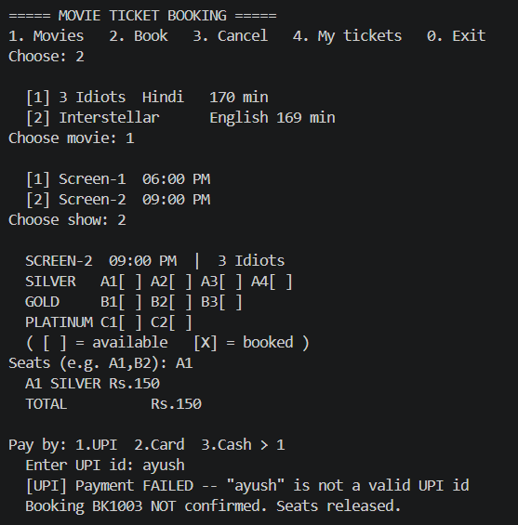

Edge Case 3:
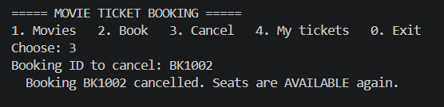

Edge case 4:
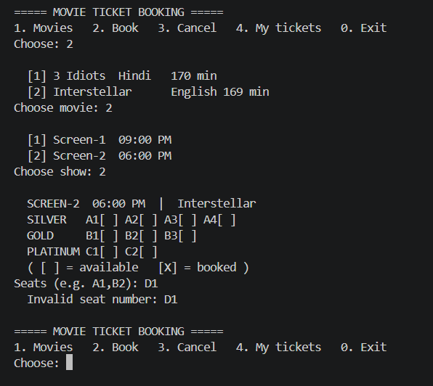

Solid Principle Mapping and Design Trade Off:

Single Responsibility Principle(SRP):
Applied in: TicketPrinter.
Justification: TicketPrinter has exactly ONE responsibility—formatting and displaying the ticket output. It does not handle seat locking, price calculation, or payment verification. If the visual layout of the ticket changes in the future, only this class will be modified, ensuring formatting concerns remain separated from core business logic.

Open/Closed Principle (OCP)
Applied in: Payment abstraction hierarchy (UpiPayment, CardPayment, CashPayment)
Justification: The payment framework is open for extension but closed for modification. If a new payment gateway (such as NetBankingPayment or WalletPayment) is added, it can be created as a new derived class extending Payment. The orchestrator (BookingService) will not require any code modifications to support additional payment methods.
Liskov Substitution Principle (LSP)
Applied in: Polymorphic Payment hierarchy
Justification: Every derived payment class (UpiPayment, CardPayment, CashPayment) strictly honors the contract defined by the base class Payment. BookingService interacts with payment objects through a base class reference/pointer (Payment*), and any subtype can substitute the base class at runtime without breaking the application logic or requiring type-checking blocks.
Dependency Inversion Principle (DIP)
Applied in: BookingService -> Payment interface
Justification: High-level orchestration modules (BookingService) do not depend directly on concrete low-level implementations (e.g., UpiPayment or CardPayment). Instead, BookingService depends on the high-level abstract interface (Payment), keeping the orchestrator loosely coupled from payment execution details.

Deliberate Design Trade-off (What Was Deliberately NOT Done)
Deliberate Anti-Pattern / Skipped Feature:
Persistent Database & File Storage Layer (SQLite / Serialization)
Engineering Justification & Trade-off Analysis:
Why it was omitted: Implementing an external database or binary file I/O layer would introduce external library dependencies and runtime setup complexity for a single-session console CLI program.
The Trade-off: Omitting database persistence means booking records exist only in-memory during execution and reset when the application closes. However, this trade-off deliberate keeps the execution environment lightweight, dependency-free, and purely focused on object-oriented system design, class hierarchies, and memory management as required by the assignment guidelines.

